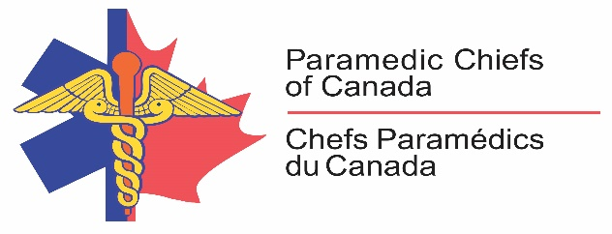

Position Statement

Violence against Paramedics in Canada

Position
Violence against Paramedics is unacceptable. The Paramedic Chiefs of Canada (PCC) supports a zero-tolerance position on all forms of violence experienced by paramedics and support staff.

Situation
In Canada, over 30,000 paramedics and communications officers stand ready to respond to people in need and to save lives. Each day as they perform these tasks with compassion and dedication, these same individuals are at high risk of being victims of violence and abuse.

In the line of duty, Paramedics are exposed to physical and verbal violence, bullying and threats, sexual assault and harassment. Physical violence includes pushing, punching, scratching, kicking, slapping, biting, or the use of weapons. Sources of violence include patients, family/friend and bystanders.

Assessment
Internationally, studies have found that between 55% and 83% of EMS personnel have experienced threats or violence during the performance of their duties (Maguire, O'Meara, O'Neill, & Brightwell, 2018; Pourshaikhian, Gorji, Aryankhesal, Khorasani-Zavareh, & Barati, 2016).

In 2014, in a study of Canadian paramedics, 75% reported experiencing violence, with 74% reporting multiple forms of violence. Of the n=1676 paramedics responding, 67% reported verbal abuse, 41% reported intimidation, 26% report physical assault, 4% report sexual harassment, and 3% report sexual assault (Bigham et al., 2014).

Workplace violence experienced by Paramedic personnel has been linked to psychological injuries in the form of stress, anxiety and PTSD (Bernaldo-De-Quirós, Piccini, Gómez, & Cerdeira; Duchateau, Bajolet-Laplante, Chollet, Ricard-Hibon, & Marty, 2002). Further, workplace violence has been linked to decreased job satisfaction in paramedics and an intent to leave the profession in healthcare professionals (Brough, 2005; LeBlanc & Kelloway, 2002). Violence targeting paramedics jeopardizes the quality of patient care that paramedics strive to deliver. It also leads to immense financial loss in the health sector.

Recommendation
Interventions to prevent violence needs to occur at multiple levels.

- Research is required to obtain a better understanding of the scope of the problem in Canada, to evaluate the impact of violence on personnel and to assess means of mitigation.
- Evidence informed strategies must be developed and training provided for management of violent patients and situations to protect frontline staff.
- Increase public awareness of human and financial impact of this issue.
- Consideration must be given to changes in policy and legislation to protect paramedics through increased punitive measures where appropriate.

Citations

Bernaldo-De-Quirós, M., Piccini, A. T., Gómez, M. M., & Cerdeira, J. C. Psychological consequences of aggression in pre-hospital emergency care: Cross sectional survey. International Journal of Nursing Studies, 52(1), 260-270. doi:10.1016/j.ijnurstu.2014.05.011
Bigham, B. L., Jensen, J. L., Tavares, W., Drennan, Ian R., Saleem, H., Dainty, K. N., & Munro, G. (2014). Paramedic self-reported exposure to violence in the Emergency Medical Services (EMS) workplace: A mixed-methods cross-sectional survey. Prehospital Emergency Care, 18(4), 489-494. doi:doi:10.3109/10903127.2014.912703
Brough, P. (2005). Workplace violence experienced by paramedics: Relationships with social support, job satisfaction, and psychological strain. Australasian Journal of Disaster and Trauma Studies, 2005(2), [np].
Duchateau, F. X., Bajolet-Laplante, M. F., Chollet, C., Ricard-Hibon, A., & Marty, J. (2002). Exposure of French EMS providers to violence. Annales Francaises d'Anesthesie et de Reanimation, 21(10), 775-778.
LeBlanc, M. M., & Kelloway, E. K. (2002). Predictors and outcomes of workplace violence and aggression. Journal of Applied Psychology, 87(3), 444.
Maguire, B. J., O'Meara, P., O'Neill, B. J., & Brightwell, R. (2018). Violence against emergency medical services personnel: A systematic review of the literature. American Journal of Industrial Medicine, 61(2), 167-180. doi:doi:10.1002/ajim.22797
Pourshaikhian, M., Gorji, H. A., Aryankhesal, A., Khorasani-Zavareh, D., & Barati, A. (2016). A systematic literature review: Workplace violence against emergency medical services personnel. Archives of trauma research, 5(1).

